Experiencing a Spiritual energy and manifesting this through Artworks

___________________________________________________________________

Milena Smith
__________________________________________

20244900

Dissertation submitted for the Degree of BA (Hons) Fine Art

____________________________

2022/2023

List of Contents

Acknowledgement 2
Research Approach Methods 3
Abstract 4
Introduction 6
Chapter One Could Be Spirituality Measured Through Art? 7 - 25
Chapter Two Experiencing a Spiritual Energy and
Manifesting this Through Artwork 26 - 48
Conclusion 49
Bibliography 50 - 65

2
Acknowledgement
Through this appreciation, I am expressing immense gratitude to all the tutors from Blackburn College who influenced, supported and helped me through this extraordinary journey I needed to experience to get to this moment and knowledge.

3
Research Approach Methods
The research methods for this dissertation work are mainly secondary. I intend to web search, read literature, and journals, visit galleries, museums, artist studios, conversations with artists, recordings, note-taking, videos and audiobooks.
I chose the work of Wassily Kandinsky, Paul Klee, Hilma af Klint, Jaume Plensa, Antony Gormley, Jackson Pollock and Marina Abramovic because I felt that these artists were the best examples of people whose practice explores some of the themes I am writing in this dissertation.

4
Abstract
In this dissertation, I look in detail at a range of artists across the centuries whose work has a deep and strong connection with concepts of spirituality.

I explore the development of these ideas and show how the different expressions of modes of the spiritual have developed in both abstract and figurative forms.

5
Introduction
The research behind this dissertation began when I first attended Life Drawing Classes at Blackburn College in 2016. Although I was unaware of the journey of discovery at the time, these classes would take me to research spirituality and the artists whose inner being impacted their work and life. The practice then started to unravel notions about why artists create art. I began to question what is the drive for endless inspiration that supports the artists' practice. Hence, this dissertation, inspired by my experiences, reflects on my practice. So, naturally, I began curiously searching for other artists, what drove them to create art, and if there were glimpses of their personal experiences expressed in their art. Retrospectively, asking those questions prompted and supported this written work.

Throughout this dissertation, I will investigate the spirituality behind the artwork of chosen artists. The notion supports the belief that artists project their spirituality into their work through their inner being, and the impact of experiences manifests in their artwork. By the end of my written work, I intend to find answers to my questions about whether the inner human being and spirituality are the sources of inspiration in artists' practice.

6
Chapter One
__________________________

Could Be Spirituality Measured Through Art?

The abstract description of an artwork we perceive visually should function as a guide to the understanding and realisation of the more profound senses of the viewers' experience. The viewer can think about it and, with the analysis, associate the image with their perception to process and create their understanding. Nevertheless, is the psychic and spiritual connection consequently manipulating our perception? Dr Callaway stated in his article Measuring the Spiritual Dimension of Art:

'Aesthetic experience is not only a pathway to spiritual understanding, the two are inextricably linked. We build our ethical and spiritual understanding of the world first through our understanding of beauty, the traditions and structures of religion come later.' (Callaway K. 2020, online)

Dr Callaway is interested in good versus bad art, profound masterpieces versus kitsch. Is it possible to measure an artwork's excellence and affect how it evokes a spiritual response in the viewer?

7
According to Derek Smith, visual art will serve in this project as the anchor for the research. The artist commissioned for this project took photographs of work of high and less artistic value to enable researchers to measure reactions to an image of different aesthetic quality. (Smith D. 2020, online)

However, the project raised another notion about the psychic understanding humans are exposed to and challenged during their lives. This notion led the research to John Berger's book Ways of Seeing.
Berger stated that visual perception is the first interpretation of our world. The world around us and the influence we are exposed to affect our lives and how we think reflects our behaviour. These collected impressions over time reflect how we perceive and interpret art.

'Yet when an image is presented as a work of art, the way people look at it is affected by a whole series of learnt assumptions about art. Assumptions concerning: Beauty, Truth, Genius, Civilisation, Form, Status, Taste.' (Berger, 1990, online)

Berger stated that visual perception is the first interpretation of our world. The world around us and the influence we are exposed to affect our lives and how we think reflects our behaviour. These collected impressions reflect how we perceive and interpret art and how artists manifest their work through these experiences. People are unique and react differently to exposure to different things and situations. For example, some people could see women's nude pictures as appalling, and some find women nude as beautiful and poetic, reflecting fertility.
8
'Drawn from the soul, or core, or spirit; the highly conscious centred ego; or a whispery chalky voice in the ear; or a thin and miserable individual childhood; or the osmotic and transparent clear grey light that is the palimpsest of prairie winters.' (Walsh, 2018, online)

Walsh's statement indicates that the natural influences of society, status and culture affect the outcome of whatever humankind creates. This statement also supports Berger's quotation and reminds us that,

'the relation between what we see and what we know is never settled.' (Berger, 1990)

Driven by the imprints gathered on people's way to adulthood are constantly changing. Those elements shift the perception of seeing and the meaning of art to a specific interpretation of individuals.
All novelties, especially in modern art, risk alienating a large part of the population. Suppose more people were exposed to diverse ways of thinking and seeing that contemporary art could give us access to more possibilities. In that case, we can close some of the constrained ideologies that divide us. For example, the degenerative art exhibition that I will write more about later in this chapter.
Some artists unconsciously or consciously express spirituality through their artwork which manifests in their unique way. Because of those aspects, Kandinsky, Klee, and Klint infused elements to embody the transformation of abstract art and their philosophy into their work.

9
Hilma af Klint held her work back from the public eye because she believed that public
perception needed to catch up for her work to be accepted. Likewise, Paul Klee initially thought people would not understand his work. Then another negative perception was when Klee's and Kandinsky's artwork was classified as degenerated by Hitler.
Hitler despised contemporary art because it expressed humanity and showed aspects of human nature, which were in total opposition to the oppression of fascism. Although these artists were affected by the complete lack of spirituality, driven by their beliefs still wanted to share it with the public domain through art. Nevertheless, the artists followed their path or the so-called callings of internal intuition and sensation despite anyone's opinion.

Spirituality is generally challenging to manifest through art without being figurative, perhaps because of the strong connection to iconic figures and symbols. The old masters expressed spirituality in art with symbolism, ideal beautiful images of gods, goddesses, angels, saints, and religious scenes of heaven and hell. How could the artists express spirituality without being figurative? What is the definition of spirituality? According to Elizabeth Scott, PhD,

'Spirituality is the broad concept of a belief in something beyond the self. It strives to answer questions about the meaning of life, how people are connected to each other, truths about the universe, and other mysteries of human existence.' (Scott E. PhD, 2022)

All humans can experience and perceive spirituality differently. Their perspectives can reflect and affect art uniquely in the modern world.

10
For example, some people believe that a higher power or spirituality is the practice of a specific religion. Spirituality could involve experiencing a connection to a higher state or a relationship with the rest of humanity, nature and connectivity.

11
Hilma Af Klint (1862–1944)
The Swedish artist, Hilma af Klint, studied Fine Arts at the Royal Academy. However, Hilma af Klint rejected her formal training in favour of spiritualism and joined the Theosophical Society Madame Blavatsky in 1889. (Forrest J. 2019) Hilma af Klint is an artist inspired and motivated by spirituality, likewise Klee and Kandinsky. Dalya Alberge stated in her article Hilma af Klint: Swedish mystic hailed as the true pioneer of abstract art.

'As a clairvoyant and mystic, Af Klint believed that her abstracts were painted under the direction of higher spirits and that the world was not quite ready for her radical art. Still, she probably never foresaw such posthumous acclaim.' (Alberge D. 2022)

Hilma af Klint was a female artist credited as an abstract pioneer before Kandinsky. Daniel Birnbaum, who curated the Serpentine Gallery Show in London in 2016, told the Observer:

'She saw her art as a spiritual message to mankind. However, she had much bigger ambitions.' (Alberge D. 2022)

Hilma found inspiration in the mysticism and spiritualism of Theosophy and Anthroposophy and attended spiritual gatherings with four female friends in a group called The Five. The group of women was exploring spiritual realms through meditation and seances. Then, believing they could communicate with mystic beings. They transcribed their messages through automatic writing and drawing, experiments that predated the surrealists by the advance through art movements. (Alberge D. 2022)
12
According to Alberge, D. Hilma af Klint's bigger ambitions wanted people to see the higher truths from her spiritual experience executed through art. However, her beliefs in spiritual realms accessed by unordinary methods such as meditation or seances probably alienated her from the public eye. The public did not accept this radical approach. Another aspect of rejecting Hilma's artwork is that she was a female, and the position of a woman artist in that era was difficult. Therefore, the support and publicity for Hilma from the art association were improper. However, it could make a difference if Hilma exhibited her work more actively. Listening to and following her intuition, Hilma kept her work more private than other fellow artists.

In 1904 during a séance, Hilma claimed to have heard a voice telling her to make paintings 'on an astral plane'. In November 1906, at age 44, Hilma af Klint began creating The Paintings for the Temple, Fig,1, which includes several series of paintings on various themes. The visual interpretation of those three paintings resonates with the cosmos. The three paintings stand out for their representation of place as a temple, where all the creation originates. The first preparatory group, Primordial Chaos, Fig,2. consisted of twenty-six small pictures. The style breaks free entirely from representation, combining geometric shapes such as spirals with dynamic brushstrokes, letters of the alphabet and symbols. (Priestley P. 2021)

13
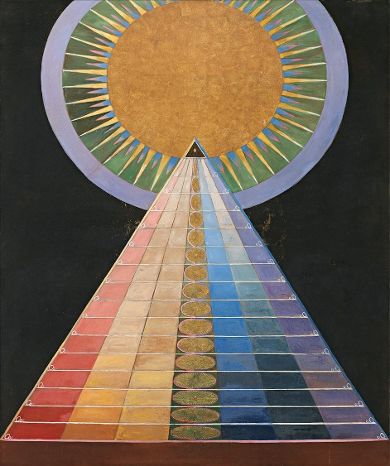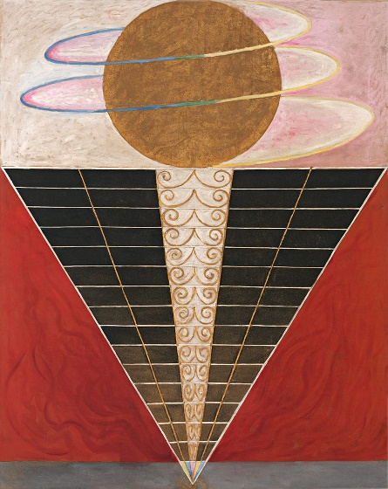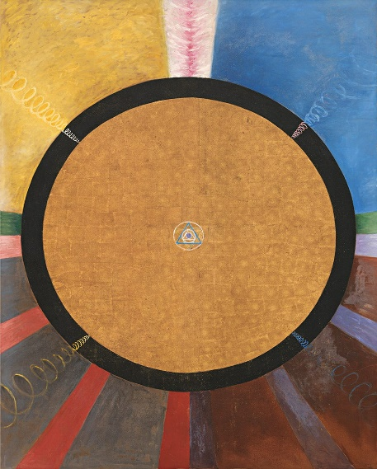
Fig,1

Klint H. A. “Paintings for the Temple” (1906-1915) Fig,1 (Paintings for the Temple | The Guggenheim Museums and Foundation)

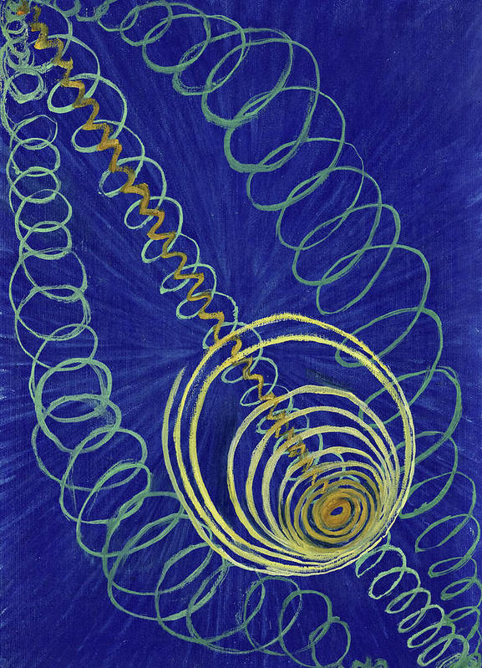
Fig,2
Klint H. A. “Primordial Chaos” (1907) Fig,2 (Primordial Chaos, 1907 Art Print by Hilma af Klint - Fine Art America)

14

The Paintings for the Temple, Fig,1. should diagram the universe in a temple. It took Hilma 10 years to finish a series of 193 paintings. The paintings represent everything from the universe's origin to the evolution of the contrast and unity of the masculine and feminine. In addition, the artwork expresses the stages of life, which is a way of communicating through the inner being. Her paintings combine many aspects of scientific illustration, geometry, colour association, and communication through the Theosophy for organic forms. Klint's paintings were not just a combination of these elements. Hilma af Klint drew inspiration from the astral world of the invisible. Her use of colour and form was not a means to themselves, unlike Kandinsky's descriptions of colours and lines. The compositions in her work represent abstract concepts. Each piece's colour, shape, and arrangement could be interpreted as not abstractions but visual descriptions of delicate images outside human sensory recognition. (Forrest, 2019, online) Hilma af Klint understood that her work needed to be comprehended better by the public audience at that time. Therefore, Hilma wished to keep her artwork hidden for 20 years after her death.

15
Wassily Kandinsky (1866-1896)
The Russian-born Wassily Kandinsky is one of the artists who experienced a spiritual sensation. Spirituality was central to Kandinsky's entire direction, which also links conceptually to my work. Kandinsky believed that materialism could cloud the perception of spirituality and leads people to lose humility and general perspectives. It is questionable, but it is more likely that materialism could negatively influence some people's perceptions and emotions.
Kandinsky believed that freedom from materialism is how to attune to a spiritual domain. He also believed that art expressed with lines, colours, and rhythm can access a different awareness dimension. (M.T.H. Sadler 2009)
At the beginning of Kandinsky's painting career, his work was orientated to landscapes and iconic Russian motives, with pointillism's experimentation. He started to study art in his 30s. Kandinsky's abstract painting named Cossacks (1910-1), oil on board, Fig,3. drew my attention. The name is originally from ethnic nomadic tribes, meaning Free Man.
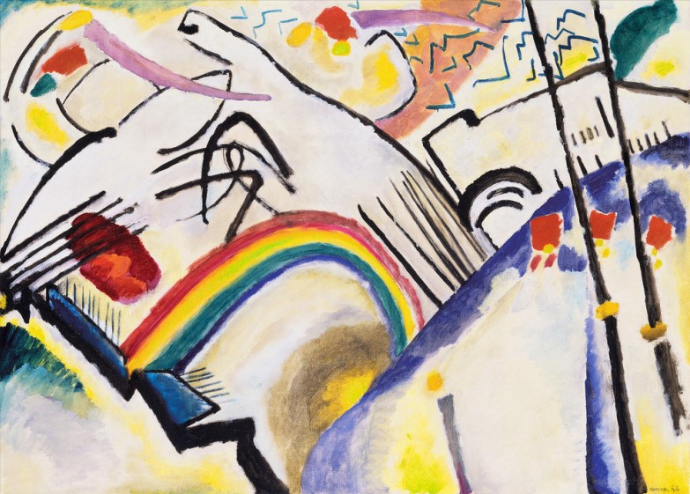
Fig,3
Kandinsky W. “Cossack” (1910-1) Fig,3 (Cossacks, 1910-11 Art Print by Wassily Kandinsky | King & McGaw (kingandmcgaw.com)
16
Free Man is probably from the Turkic word Kazak. The Russian cavalrymen, so highly skilled riders, are captured with just the glance of brown/orange-coloured hats on the right-hand side in the middle of the painting. The blue colour is somehow dominating the overall view of the painting. Black marks and directional lines are dynamically creating a solid sense of rhythm and depth. In Concerning the Spiritual in Art, Kandinsky compared the blue colour to the supposedly heavenly sound of the pipe organ. We can see the communicated connection to spirituality with the strength of the colours in the painting. Professor Shaw stated in his essay that Cossacks, Fig,3. is an expression of Kandinsky's belief in the power of art.

'to awaken this capacity for experiencing the spiritual in material and abstract phenomena'. (Shaw, 2017)

Kandinsky expressed the movement of the riders with strong dynamic marks that also created rhythm in the painting. The vibrant abstract form conflicts with the reality and manifestation of the friction between the forces of political oppression.

'Kandinsky was deeply moved by the experience of a pogrom, destruction and violence to the one unleashed against the Jews of Odessa in the Russian Empire in 1905. It triggered the desire for spiritual rejuvenation to affect the rise of soulless modernity or materialism.' (Shaw 2017)

Kandinsky's transformation from a traditional or iconic connection to spirituality is described in his book Concerning the Spiritual in Art.
17
He emphasises and compares colours and sounds and connects them to emotions and visual associations. For example, he was comparing yellow to aggression, the earthly sound of a trumpet. As mentioned previously, the blue colour is associated with the supposedly heavenly sound of the pipe organ, which somehow dominates the painting and indicates a visual interpretation of spirituality. Kandinsky also analysed the effects of the abstract elements of drawings on his perception. The interpretation of a horizontal line is, for example, as cold and a vertical line as hot. We can also see these dynamic lines creating movement in the Cossacks, Fig,3. (Rodriguez, 2019) The analysis of those marks is the interpretation of spirituality according to Kandinsky and manifested through his work.

18
Paul Klee (1879-1940)
Klee was a Swiss-born German artist, and the communication of spirituality reflects in his work, likewise Kandinsky's and Klint's. According to Mark Wrathall, Paul Klee aimed to use his art to allow viewers to 'penetrate deeply' into the 'cosmic sphere' so that we come out of it as changed observers and then 'wait for things'. (Parry 2010:28)

Klee's statement refers to a meditative state. For example, while looking at an artwork, some people tend to zoom into a state of serenity where they can profoundly perceive the art, which could help the viewer connect with the 'cosmic sphere'. However, tuning into the cosmic sphere or energy is another aspect of painting, creating with the process of experiencing. I will write more about the two very different temporal states in Chapter II.
Moholy-Nagy described Klee's communication with nature 'as the essence of his work', and all actual creation is a thing born out of nothing, which is the spiritual cause and connection. (Moholy-Nagy 1953:8)

Klee preached:
'When they are ready to move on to higher things, guide your pupils towards nature into nature. Make them experience it, how a bud is formed, how a tree grows, how a butterfly unfolds, so that they may become just as resourceful, flexible, and original as great nature. Looking is a revelation that is an insight into the workshop of God. There, in nature's womb, lies the secret of creation.' (Nohra Corredor, 1999)

19
This poetic statement linked Klee's other light and dark study When God Considered the Creation of the Plants (1913) Fig,4, pen, brush, and watercolour on paper on cardboard.

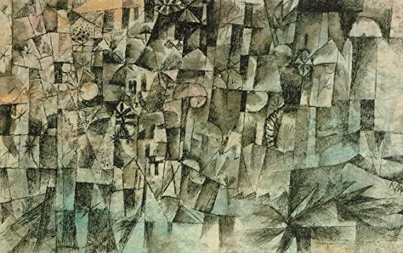
Fig,4
Klee P. “When God Considered the Creation of the Plants” (1913) Fig,4 Paul Klee God Considered Creation 1913 b12399 A3 Canvas - Stretched, Ready to Hang (16/12 inch)(41/31 cm) - Movie Film Wall Decor Art Actor Actress Gift Anime Auto Cinema Room Wall Decoration : Amazon.co.uk: Home & Kitchen

Klee stated that it is easier to work with white colour because nature works with white; 'without white wouldn't be light'. With fable according to which God approaches the darkness with his famous 'Let's there be light' makes good sense. God was not concerned with chaos more than the artist. Impressed with the concept of space and volume of Cubism, Klee worked on the organic world's pictorial segmentation in this painting. (Baumgartner 2015, pp269/270)
20
The combination of musical notations in the image displays Klee's passion for music. Music was always essential to Klee, which also reflects in his work.

'Like the French Neoclassical artist Jean-Auguste-Dominique Ingres (1780-1867), he regularly played his violin for the least an hour to warm up before every painting session'. (Hodge 2014:15)

The essence of spirituality is the energy Jean-Auguste-Dominique Ingres and Klee tried to incorporate into their work through art to connect with the invisible power. However, for Klee, communication with nature as and source of inspiration was the centre of his work.
Music played an essential role in Klee's and Kandinsky's lives, which could visually be perceived in both artists' work: the musical notations and the grids and lines in Kandinsky's paintings. Klee's musical notes in The Twittering Machine Fig.5, the little singing bird's nature's music creators, are the visual proof of the correlation. Paul Klee's philosophy was that art is not perceived only through the physical aspect; he described; another way to sense an artwork, 'art in the highest circle'. (Perry, 2010)

21
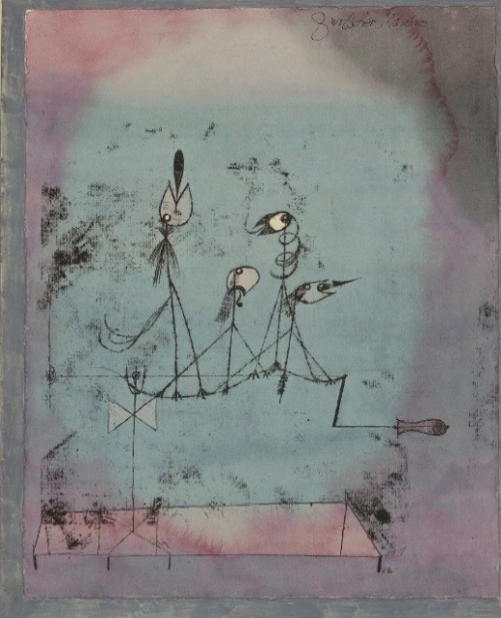
Fig,5
Klee P. “The Twittering Machine” (1922) Fig,5 (Paul Klee. Twittering Machine (Die Zwitscher-Maschine). 1922 | MoMA)

In Paul Klee's autobiographical text, he wrote for the art historian Wilhelm Hausenstein,

'I cannot be grasped in the here and now,' or, alternately translated, 'I cannot be understood on this earth.' (Walsh, 2018)

After the atrocities of the First World War, the world was full of new explorations and searches for the unknown and unseen. The political events affected more than just the artists. The horrors of the events impacted the whole world and people's perceptions of everything, as they would try to find an explanation of what did happen during the horrific time. The avant-garde movement started to unfold new possibilities in art. The world changed, and people welcomed the move forward to escape the terror events that badly affected people's lives.
22
Perception of art with an absence of spirituality.
A revolutionary move swept across Europe at the end of the 19th century. A new art style developed in Russia, and millennia of artistic tradition swopped for the modern and avant-garde movement. Stalin disliked contemporary, Avant-garde art and censured the art domain for being acceptable to communist ideology and standards. Socialist Realism was the style for painting, film, music, literature, and even architecture. In 1922 The Association of Artists of Revolutionary Russia was born. The artists used words such as Proletariat, Peasants, and Revolutionaries. Artists had to express the glorification of the Communist Party through art backed up and approved by the state. By the 1930s, the avant-garde movement disappeared and was despised by the regime as elitist and inaccessible, an art form foreign to people's tastes. Social Realism became the dominant style of art in the Soviet Union between the 1920s and the 1960s. (Then & Now, 2017)

The art had to attain the criteria for communist values, which needed to be realistic, idealistic and educational. Paradoxically, the rejection of progress towards the future and advances in art contradicted the importance of the communist party. The Communist Party ideology is that people are supposed to treat others without differences and equalise the social gaps, which should give people a better quality of life. An ideal world where people share everything equally sounds like a perfect spiritual world. However, finding a state of universalism in the late modern capitalist system is proving challenging and impossible because of the human condition. Artists express their spirituality by connecting to different elements that affect their lives—for example, music, nature creation and inner beings.

23
Connecting and listening to our inner being could allow us to manifest an art more profoundly. For example, Klee and Kandinsky expressed spirituality through their work concerning living beings and nature. However, their artwork was rejected by Hitler, who labelled the work as degenerated. Was it the new abstract movement that most of the public needed to understand and comprehend? Hitler had an agenda. The short film Degenerated Art Exhibition tells how Hitler always wanted to be an artist and tried to get into the Academy of Fine Arts in Vienna. However, he was refused, not once, but twice. His work was considered realistic, resembling excellent postcards compared to the much more popular germen expressionists of that time. This could lead him to build much resentment against modern art. (The Canvas, 2019, Film)
It almost appears that he tried to kill contemporary art by humiliating and convincing the public that it was not suitable artwork for people to admire and enjoy. In contrast to the artists' work, the exhibition expressed no trace of humanity and spirituality. In addition, Hitler's completely failed as a human being. His actions towards humankind prove that he acted utterly without any sign of spirituality, driven by human conditions.
Whether it is possible to measure spirituality through art still needs to be determined. I am scraping the surface here. There is no straightforward answer to that, as we are exposed to different aspects that affect our thinking and perceiving art that challenge the connection between aesthetics and spirituality.

24
At the beginning of this chapter, I started by considering the experiment of measuring spirituality in art. Unfortunately, there are no results from this study, and it is inconclusive whether we can measure spiritual art perception. However, from observing the work of my three chosen artists, we can argue that art has a unique potential to express something about the human condition that other mediums cannot capture.
When individuals choose to like art by looking at the work, which can create feelings that evoke inner harmony, it floods them with an indescribable sensation that viewers follow their choice through intuition instead of learned form. However, Klee's, Kandinsky's, and Hilma Af Klint's artwork were created to tune into spirituality in a cosmic sense. By describing what colours mean in the world and how spectrums resonate universally. Those three artists were also influenced by impressions of European culture, with lineage history reflected in their art.
The spiritual elements encoded into these artists' work can also find their way through the work as a channel and profoundly affect the viewer, which can create feelings. There is another energy transmission element through the artists' inner being in created artwork. I will expand on energy projection in Chapter II through the artist's manifestation.

25
Chapter Two

Experiencing a Spiritual Energy and Manifesting this Through Artwork

This chapter will explore the notion I believe that all humans express and then project spirituality through their work, albeit unconsciously. In addition, this chapter intends to investigate how certain essential experiences in the life of an artist can be unconsciously manifested through art.

The artwork of some artists is a way of experiencing a metaphysical truth which is not accessible in any other way. The lived experience in making artwork, especially in performance art, is a portal into hidden energy. The energy that connects something transcendental through the artwork is conveyed in the piece's manifestation. The search for connections to the core of human beings, to energy expressed through their art practice, could be perceived in performative work, for example, of Marina Abramovic and Jackson Pollock. Although I believe humans are spiritual beings, the phenomenon I sense in the artwork of those artists might not be perceived by other viewers.
The researched subject originates from personal experience, which convinced me that humans could transport themselves through regular breathing to the spiritual or different dimensional realm. The experience of transforming the spirit from the physical body happened unexpectedly without prior knowledge of the phenomenon.
The personal experience started with creating a breathing pattern that helped the body stay behind whilst the spirit consciously travelled through the air.
26
The intense unconscious concentration on breathing patterns enabled the energy to leave the physical part and travel as a spiritual being. The sound of breathing with attention could be how the pattern was kept in regular order and reached the transmission into another realm. The breath is infinite, as is the heartbeat (until the time for rest comes). However, it is possible to slow or speed up breathing and the heartbeat with limitations. The heart is physical. Unlike the breath, we can feel the air power and the flow while breathing in and out. The breath represents the window to the other-dimensional world we cannot yet access quickly or easily.

Astral life is a fascinating phenomenon that leads to awareness and consciousness. The supernatural ability of human beings raises the question of whether this aspect could affect our perceptions of communication through art. (John Kreiter, 2016)

27
Jaume Plensa (1955)
Plensa grew up surrounded by books and poetry that influenced him and his work. He drew inspiration from poets such as; William Blake, Canetti, Goethe, Shakespeare, Estelles and others. (Lilley C. 2011) The inspiration from poetry is what he also visually articulated in his work. For example, the Silhouettes, Fig. 6 is a sculptural installation of stainless steel with 16 figures dimensions. His work is highly evocative with a solid conceptual basis. Plensa's sculptures provide tangibility to his ideas. The sculpture Dream Fig,7. is a visual manifestation of poetry through a tangible medium. Plensa describes in a conversation with Clare Lilley what inspired him to name the sculpture Dream Fig,7.

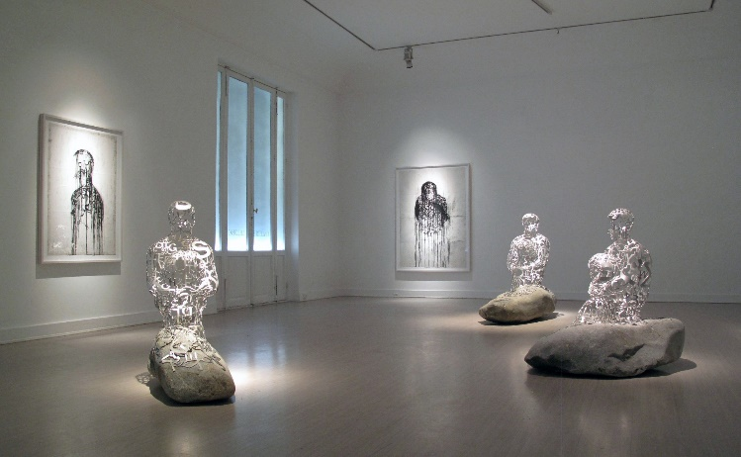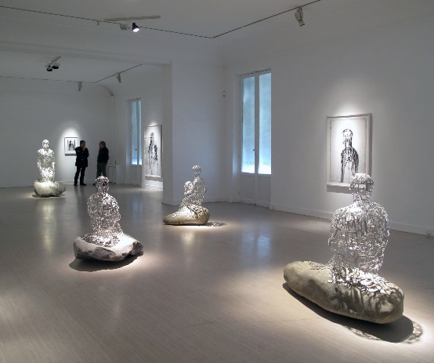

Fig,6

Plensa J. “Silhouettes” (2009) Fig,6 (SILHOUETTES Galerie Lelong & Co. Paris, France - Exhibitions 2012 | Jaume Plensa)

28

'In St Helens, an ex-miner told me, Jaume, you can't imagine how deep the darkness is when you are inside the pit, it's so dark that light becomes a dream.' (Lilley C, 2011)

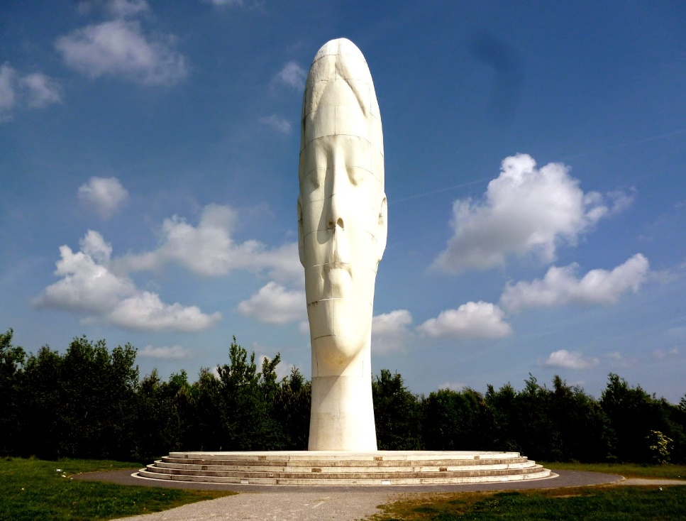

Fig,7
Plensa J. “Dream” (2009) Fig,7 (Dr Tony Shaw: Jaume Plensa's Dream, Sutton Manor, St Helens, Merseyside (tonyshaw3.blogspot.com)

Although distorted, this beautiful, delicate, and peaceful sculpture apparently contrasts with the horrific and brutal trade that is mining. The artist intended to balance the instability in emotions created by life and to depict the miners' dream of light while working underground.
Artist Plensa prompts the public through his sculptures to breathe, meditate, and perhaps, take the time and listen to our inner being with closed eyes.

29
The concept resonates with my work sculpture/s, a Zen-like impression that the statue/s would make the viewers zoom out of this world and enable them to visit the inner world through inner peace. This concept also resonates with the artist Marina Abramovic's work, which I will write about later in this chapter.
The monument of pure white sculpture became a North West symbol, just as Antony Gormley's celebrated Angel of the North, Fig,8. is now synonymous with the North East. St. Helens Council Liverpool Biennial for Contemporary Art U.K. 2007 commissioned the project and created the sculpture in 2009. The Dream, Fig,7. is 20m tall and weighs 500 tons, made from concrete and Spanish dolomite; the Dream looks weightless despite the weight. The Dream depicts a young girl's head with her eyes closed in a dreaming state. (Lilley C, 2011)
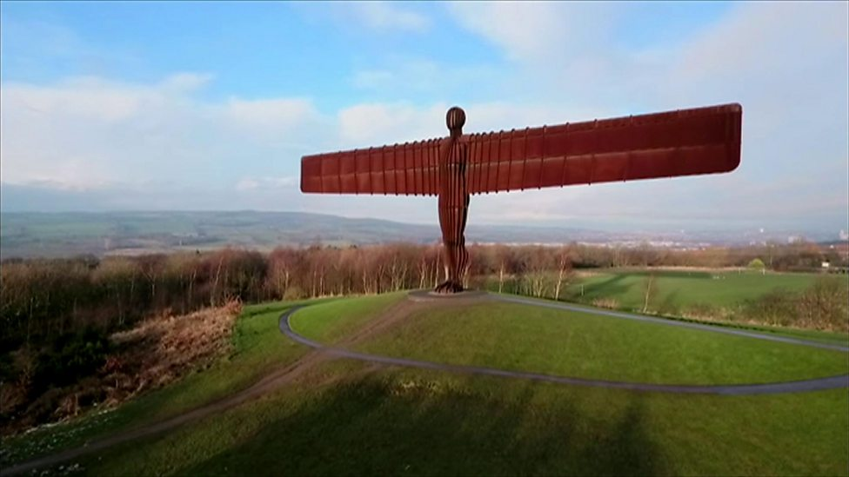

Fig,8
Gormley A. “Angel of the North” (1998) Fig,8 (angel of the north - Google Search)

30
The concept contrasts not just with the medium elements but also determines the feelings and gives the sculpture a spiritual context. Plensa reflects on spirituality and humanity by manifesting the Dream, in a Zen-like or meditative appearance to connect with an inner being through his work. The connection to my work is the intention to incorporate the human element from the visual and inner perspectives. The installation of sculptures, the public involvement in their presence, and the time they stop and listen to the breathing and heartbeat soundtrack are the connection between Plensa's work and the project I am working on. The public's participation is also their presence performed unconsciously. The aim is to connect the sculpture/s with the viewer through the invisible and mysterious energy human beings possess.

The word spirit comes from the Latin spiritus, meaning 'breath.' The word also carries meanings of 'soul,' 'courage,' and 'vigour.' In its most technical sense, the term spiritual refers to aspects that affect the human spirit or soul, as opposed to the things of the physical, material world. (Ungvarsky J. 2020)

Antony Gormley (1950)
Gormley's fascination for the human body is reflected in his work; by creating sculptures using his own body as a template to express his thoughts and feelings about humans and space. The similarities in perceptions, some artists in artwork could associate a human with the human body and the mind with the head to connect the physical aspect with the spiritual part of humans, however, unconsciously. However, there is another element in Gormley's work related to my search for an inner human being.
31
For example, Gormley's childhood memories of his parents insisting he has an afternoon nap. He was never tired enough to sleep, so he would lie there and tell himself that he had to stay still. Nevertheless, he also suffered as a child, with terrible claustrophobia as a precursor to his motionless, stiff body, particularly after being sent to a Catholic boarding school, where tightly cornered bedclothes closed him in. (Lesso R, 2019)
The strict rules with religious roots could be paralysing and restricting. After Gormley finished his studies, he decided to travel. His interest in art started after he finished his education; perhaps he was driven unconsciously by intuition and south for answers about a human being.
Gormley travelled and spent two years in India and a few months in Sri Lanka, where he practised Buddhism and meditation in monasteries. (Mohn E. 2017)
Gormley's study and practice of different cultures' religions impacted his perception of human beings and art. In conversation with Elkann, Gormley reflects on human beings' physical and spiritual aspects.

'Gormley's work is about engaging his own body into sculptures in a way that confronts questions of the connection between human beings and the cosmos'. (Elkann A. 2020)

This artist's statement suggests that these experiences impacted the work by unconsciously embodying feelings. It could reflect these physical feelings mixed with emotions in his perception and execution of his artwork.

32
Through the stillness in an awakened state could enter the meditative state and the profound tranquil energy that Sadhguru describes in his book, The Inner Engineering. It is a different dimensional world that has yet to be explored thoroughly.
Sadguru also mentioned in his book The Inner Engineering that it is essential to have a sacred place because of the energy. Why do we feel the powerful energy in areas such as churches, cathedrals or temples? Sadhguru believes this concerns the ancient wisdom of our ancestors' connection to a magical power that the places hold and project to people. (Sadhguru, 2016)
This version brought another notion about an extraordinary power sensed in sacred buildings. What if the energy projects the strength through people into the buildings? The energy from people who gather in such areas, being conscious of the sacred spaces, creates the phenomenon of sensing the energy that is impressed into space by the people. However, they could then project the cumulated energy back to others through those spaces and manifest their inner beings' energy into space and place.

'The big-picture idea is that human beings can learn things through aesthetic, artistic encounters that are unique, that impact us in a different way than reading a book or listening to a podcast. There is something about this engagement that uniquely affects us, especially as it relates to what we might call spiritual understanding. We want to isolate what it is about encountering a piece like the 'Mona Lisa' or a beautiful building like the National Cathedral that sparks something inside a person and can impact how they perceive God.' (Smith D. 2020)

33
Moreover, the energy we can sense from buildings and artwork could be the energy that the
artist incorporated into the work. This notion takes me to Walter Benjamin's Aura. Benjamin argued that the work is losing its Aura while produced in mass. Nevertheless, what if this is about something other than the work's authenticity? The energy is incorporated while making the artwork by the artist with the intention to articulate the artwork's meaning and attention to the object. The projected energy by the artists while creating the object transmits into the work, where the viewers can perceive and connect through spiritual beings.
Gormley uses the body as a template, as a place and a space of a body to express the natural conditions of human beings as a trace of the body in time. For example, his sculpture Another Place, Fig,9 reflects the sentimental and deeply emotional ties to a place we live, and Gormley manifests it through a human form. Most of his work takes the human body as its subject. In the New Statement interview, Gormley explained the concept of his sculptures.
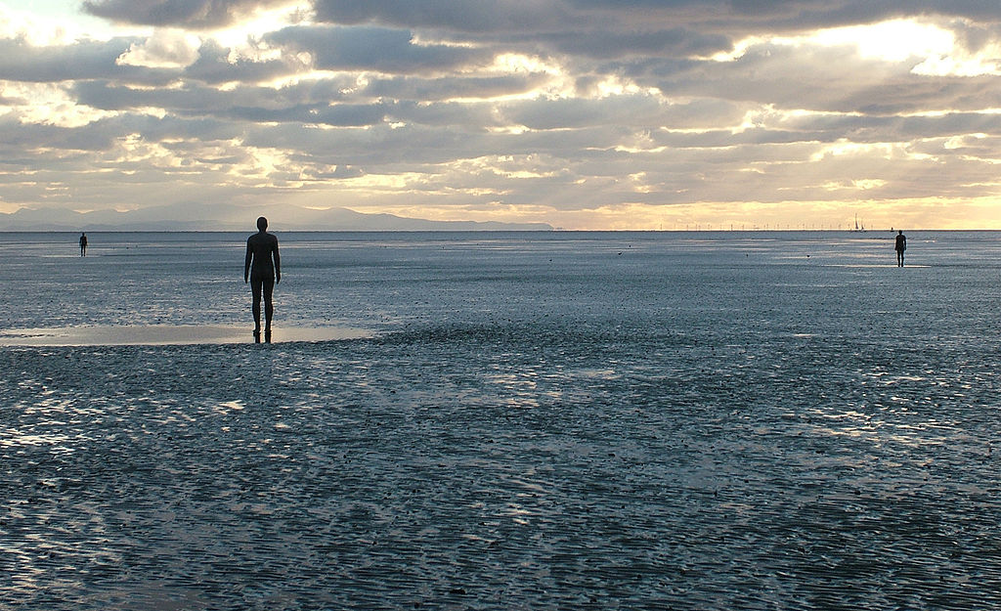
Fig,9
Gormley A. “Another Place” (1997) Fig,9 (Another Place3 edit2 - Another Place (sculpture) - Wikipedia)

34
'I am not that interested in it as a body, but I am interested in it as the place where we all live, and It's the collective, subjective condition of human beings.' (Shackle S. 2011)

Still, the human beings' symbolic element in his sculptures recalls the human form we know and naturally associate. However, the meditative pose in those sculptures is like the recollection of the inner realm of human beings. It is the recollection of the forgotten or ignored part of the human, the soul, that Gormley and Plensa convey in their work. Gormley's 100 cast-iron figures are placed to face the sea over a 2-mile stretch of beach, and each sculpture weighs 650 kilos. Gormley made the sculptures from casts of his own body, the Another Place, Fig,9 motionlessly standing on the beach looking out to sea, silently searching the horizon. In previous sculptures' displays, The Another Place was first seen in Cuxhaven in Germany, then Stavanger in Norway and De Panne in Belgium; however, the figures are now permanently established in the UK Crosby Beach. (Njatin L. B. 2000) Paradoxically, these sculptures had to travel for some time before they found their place to stay. The context has bonded with the experiences of the installation itself, as it would have to relive the concept to project the feelings realistically to the public. This aspect of realisation happened while working on my sculpture Anxiety Fig.10. The model experienced fear and anxiety while I was making a cast of a body that needed to be tightly wrapped in clingfilm and then Sellotape with a minor air source. That connection between the emotional and physical experiences somehow made the sculpture speak loudly about the concept of the work.

35
Another Place, Fig.9 is a poetic expression of sentiments associated with emigration.
The deep sense of sadness when leaving places where people lived for so long with the contrasting sensation of hope and expectation for new future links to consciousness and the unknown.
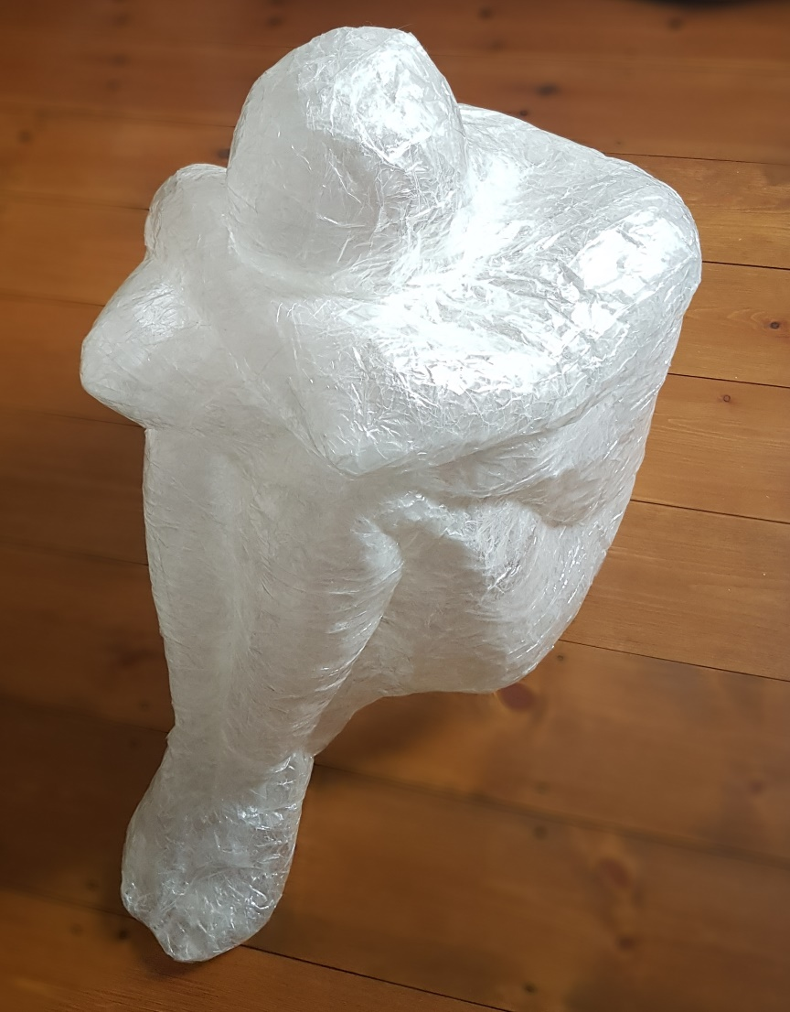

Fig,10
Smith M. “Anxiety” 2019 Fig,10 (Personal Collection)

The sculpture's profound feelings ask questions about who we are and where we came from. Also, ask what places mean to us because we all have roots in different cultures.
36
Yet, the sentimental bond is also full of memories and experiences connected to the places and time, which is Gormley's legacy. The reflection on hope and new possibilities expresses the migration with a political context. Although he wants to leave the perception interpretation to the viewer, he prompts people to think about humanity and spirituality and see the bigger picture by embedding a serenity in his sculptures.
Also, the place’s importance is in displaying work, which appears vital to Gormley. The artist pays attention, and it seems essential that his artwork resonates with the area of installation or exhibition to connect with the context profoundly and meaningfully. Gormley includes the environment in the public display, and it becomes a part of the exhibited object. Artist Jaume Plensa also works with public space. He makes his artwork accessible to everyone and includes the human being as part of the objects.

The influence of Gormley's upbringing impacted the manifestation of his work. However, Gormley’s work also shows the effect of experiences that affected his perception. The exposure to a sensation during his childhood is the element that influenced Gormley’s work. His physical involvement in and during the process of his sculptures indicates the memory of claustrophobia. It almost feels as if he wants to face and overcome the fear of being closed in space and perhaps transform the energy into a positive reflection on serenity through stillness. This conceptualisation resonates with the work of Marina Abramovic, The Artist is Present Fig,11, which I will write more about later in this chapter.
The connection between experiences and feelings can affect our perceptions expressed in our work. This extraordinary power to reveal the inner being through art and work by different manifestations unites people. However, the representation is distinctive and unique.
37

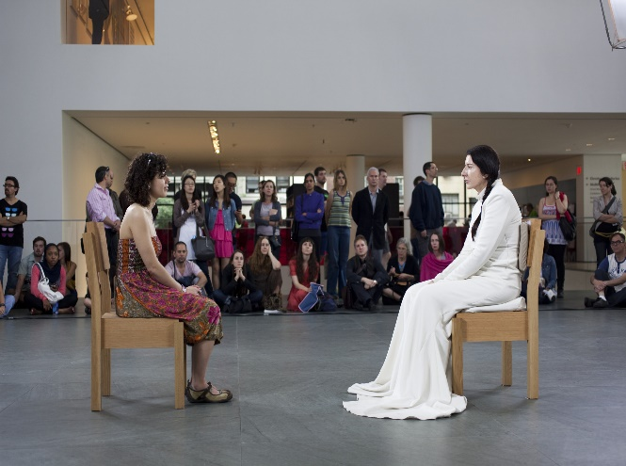

Fig,11
Abramovic M. “The Artist is Present” (2010) Fig,11 (Marina Abramović: The Artist Is Present | MoMA)

The end of WWII had varied after-effects on the psyche of the American public. The years before the war had been fraught with economic depression. Soldiers returning home from the war had seen horrible destruction, genocide, and atrocities they could not bear to discuss or contemplate. Yet, America and all affected countries were putting on a brave face. However, the inner turmoil, suffering and questioning of the meaning of life and a human's identity reflected in that era. (Landau, E. G. 2005)
38
Jackson Pollock (1912-1956)
The artist Jackson Pollock contrasts with Plensa's and Gormley's work. Pollock's drip painting is very dynamic and bold compared to the two artists. The expression of the inner turmoil that the artist incorporated into the artwork effortlessly.
Leo Tolstoy could be called the father of abstract Expressionism and the expressionist movements of the 19th and 20th centuries. His Expression Theory centred on the idea that art elicits and provokes emotion in the viewer. Tolstoy believed that the artist's role was to provide the viewer with something that would bring out these effects. Abstract Expressionism achieves this by letting the medium and composition communicate for themselves. Pollock believed that the viewer interprets the meaning of the abstract expressionist artwork through their perception and analysis. Therefore, there is no relevance to what the artist thinks or conveys while producing the work. (The Artist Editorial. 2018) Pollock's work, particularly the action painting, reflects the spontaneous, unconscious actions the artist experienced during the process. Pollock entered Manual Arts High School in Los Angeles in 1928 and came under the influence of an art teacher, Frederick John de St. Vrain Schwankovsky, who encouraged his growing interest in art and sparked his interest in Eastern mysticism. (Moose J.C. 1999)
While watching a short film on YouTube called Jackson Pollock, Action Painting, it felt like watching a dancer, perhaps a native American tribe dancer. With these unique techniques, the artist connected through movement and rhythm that created the painting in a specific way and moment. Pollock was interested in Native American culture. During the action, the rhythm resembled a connection through experience at the moment and time. It emerges as energy connects through him to the rhythmical movement that draws the artist deeper into the zone of unconscious mechanic movement.
39
Artist Jackson Pollock also faced difficulties pulling through with his drip painting method. Critics dismissed him as a fraud. They claimed that any three-year-old child could produce a Pollock "dribble" painting. Unfortunately, the public tended to agree with this assessment. Pollock's work became the target of numerous jokes, cartoons, and ridicule. As a result, he had difficulty selling his paintings. He had to rely on the generosity of his patrons and occasional financial injections to make ends meet. (Guthrie, Christopher E., 2021) However, Pollock pulled through and became a successful artist of the 20th century.
Pollock's quote from the film Pollock;

'Yes, and they did it very well. All cultures have had means and techniques of expressing their immediate aims. The thing that interests me is that today, painters do not have to go to a subject matter outside of themselves. They work from a different source, they work from within. It seems to me that the artist cannot express this age, the airplane, the atom bomb, the radio, in the old forms of the Renaissance or any other past culture.' (Pollock 2000, Film)

Action painting Fig,12 reflects the spontaneous, uncontrolled, and unconscious actions the artist makes during the process. In this sense, the painting process becomes more real and substantial than the painting itself. Action painting was a style pioneered by Hans Hofmann. He insisted that a finished painting is only the record of the intense personal feelings that an artist experienced while creating it. (The Art Assignment, 2016)
The experience while creating drip painting is significant in Pollock's work. The film Jackson Pollock, Action Painting Fig,12, is a magnificent and valuable record of the invisible energy Pollock possessed or zoomed in on while working on the painting.
40
What is more, Pollock infused energy into the work, which we can perceive while viewing the work. Pollock argued that the finished product was not accidental and that the actions were guided by internal psychic forces unleashed while he worked. Thus, the painting represented a manifestation of his inner being on canvas. (The Art Assignment, 2016) Pollock's work demonstrates a spontaneity of communication and an exciting combination of dynamic marks of colours. The rhythm let Pollock drive the movement of the paint, which spontaneously created the pattern in the painting.

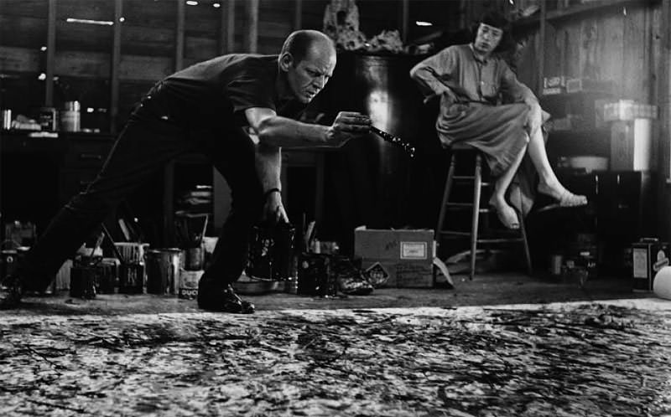

Fig,12

Pollock J. “Action Painting” (1945) Fig,12 (The 5 Most Iconic Paintings by Jackson Pollock - The Hundreds – The Hundreds UK)

41
'I continue to get further away from the usual painter's tools such as easel, palette, brushes, etc. I prefer sticks, trowels, knives and dripping fluid paint or a heavy impasto with sand, broken glass and other foreign matter added. When I am in my painting, I'm not aware of what I'm doing. It is only after a sort of "get acquainted" period that I see what I have been about. I have no fears about making changes, destroying the image, etc., because the painting has a life of its own. I try to let it come through.' (Pollock J. 2005)

Watching him in action feels like he is being drawn into an energy level where he found the ground. As a result, it gives the work another dimensional depth with the impression of the experience and the moment. The artist's concentration is astonishing, and it appeared to be almost an obsession as he would control the desire to stay in that moment and not lose the rhythm and energy. Pollock changed the arm and hand movement that manipulated the pattern but also the dynamicity of the drips. There is visible manipulation of the paint through body language and movement. However, the rhythmical pattern reminds us of regular breathing, which can help to transfer into a different dimensional world. Pollock did control the paint to some extent. However, the phenomenon of the moment combined with movement sets the experience in the spontaneous process. Jackson induced the non-ordinary state of consciousness into his work. The state of semi-consciousness in which a person is not self-aware but still capable of pursuing and realising an aim.

42
Dr Stanislav Grof & Christina Grof stated in their book Holotropic Breathwork.

'The importance of non-ordinary states of consciousness for ancient and aboriginal cultures is reflected in the amount of time and energy that the members of these human groups dedicated to the development of technologies of the sacred, various procedures capable of inducing them for ritual and spiritual purposes.' (Grof, Grof, 2010, 8-10)

Dr Grof describes that drumming, chanting, rhythmic dancing, breathing changes, and other ways of cultivating particular forms of awareness were used in rituals to connect to the non-ordinary state of consciousness. (Grof, 2010, 8-10) The connection to non-ordinary consciousness explains Pollock's argument that he created the finished product intentionally and that the actions were guided by internal psychic forces unleashed while he worked. The energy and rhythm Pollock performed while working on his drip paintings connected with the movement drew him into the zone of non-ordinary consciousness, which artists can access in the moment of making. The moment of accessing the energy is the mystic that connects the creation with the artist; through the sensation, the artist can induce the mystic in the artwork. That is the experience of power that transfers the moment and energy in work through the artist, making the piece unique and outstanding.

On the contrary, through gestures and performance during painting, Pollock attempted to communicate the human conditions. After the war, spirituality somehow diverted from the general point of view to the individuals. The terror of WWII affected the new generation, the new generation of the abstract expressionism movement.
43
The American culture influenced the manifestation of art. The new world was full of emigrants from diverse cultures and traditions, influencing the perception of art and its representation. Pollock and the Be-bop jazz players of that time oppose the convention and constraints of the 1950s. The impact of capitalist conservatism, which started to become the way of the world after the war, affected artists differently. The internal turmoil and the drinking problem that Pollock experienced during his life influenced his work and private life. All these aspects affected the manifestation of his work, and the expressive process of drip painting opened up new possibilities in the art domain.

Indian yoga guru and proponent of spirituality Sadhguru stated that our two eyes could capture the physical world,

'which can block light but are blind to all else. Only by opening the third eye can one perceive what is seen and unseen. This is the realm of mysticism, knowing life in full depth and dimension.' (Sadhguru, 2016)

The dimensional portal artists can enter through magical energy to self-surrender to obtain unity with or absorb into beliefs in the spiritual apprehension of truths beyond the intellect.

44
Marina Abramovic (1946)
Performance emerged in the 60s as a result of a challenge to paintings and media were seen as being secondary to the fine arts of painting and sculpture.

In addition, painting was perceived as the domain of men, so women artists started to work in different mediums such as performance, sound, film, installation and crafts. Marina Abramovic uses her body as a medium for artistic experiences through performance and to make a statement. Behind the execution lies the idea of purification of the spirit, aiming to pass on energy to the audience. Marina challenges the audience with sometimes violent, sometimes provocative performances. I chose to talk about The Artist is Present Fig,11 performance because of the connectivity to human beings. In this performance, Marina was in the moment, time and presence. She sat and connected with the audience through invisible communication. Marina prompts the public through this performance to breathe, meditate, and perhaps, take the time and listen to our inner being with open eyes. These elements resonate with the artist Jaume Plensa, and the perception is in his sculpture Dream Fig,7. The correlation between the people and the artist explored emotions and created spiritual sensations. This link is the element that I want to incorporate into my work. Marina's performance awakened people's feelings through this motionless and stand-still experience. During the show, there were interesting moments when Marina somehow reset her concentration and gaze before every new person came to sit with her. The artist's eyes reconnected as she wanted to transmit fresh and pure energy to connect with the new person.

45
Marina stated in the short film The Artist is Present:

'The moment you really go through the door of pain, you enter to another state of mind, this feeling of beauty and unconditional love and this feeling of there is no kind of borders between your body and environment. You start having this incredible feeling of lightness and harmony with yourself is something becomes like a Holy, I can't explain.' (The Artist is Present, 2012)

The symbolism of the human body in the work of Abramovich, Plensa, and Gormley resonates with my work. I want to connect the sculptures through the audience's senses to the core of the human being with the synchronisation of breathing, heart beating, and light. Those elements conceptionally link my work with chosen artists.

The fascinating film The Artist is Present, Fig,11 is Marina's performance of sitting on the chair behind a table and looking at a person without words and motion, resembling the sensation of falling into a trance. The reactions of some people were extraordinary. Some viewers were so emotionally affected and touched by the performance that they decided to return. Marina revoked emotional experiences in people she probably never met, strangers, but made the connection to their inner being.

Abramovic was born in Belgrade, the daughter of Yugoslavian Partisan parents. Her early performances were a form of rebellion against her strict upbringing and the repressive culture of Tito's post-war Yugoslavia.
46
Nevertheless, like all her work, ritualistic purifications were designed to free her of her past. (Wayback Machine, 2005) Marina described a fragment of her childhood in the film The Artist is Present that her mother used to beat her up for showing off. However, the artist's early age showed signs of performative and theatrical talent but, unfortunately, brutally suppressed. The effect of Marina's strict upbringing, which was regimented, without love and compassion, seemed to seek opposition or controversy in her performances to shock and challenge the audience.

Something interesting happened towards the show's end when Marina removed the table that divided the artist and audience. The comments of the security guard suggested that the artist was going to be too vulnerable and open to potential danger. Nevertheless, Marina stated that it felt right to be there without barriers. This extraordinary move indicates that Marina could experience a strong connection with the people to risk the security aspect and trust the audience based on her intuition. The artist's reaction shows that the table functioned at that moment as a restriction instead of security as the show progressed. By removing the table, the artist became closer and more exposed to the audience. Throughout the performance, Marina's trust in the audience evolved the spiritual connection and the experience of being connected.

Plensa, Gormley and Marina convey the human body as vessels reflecting human emotions. Plensa seeks inspiration in the human figure as a universal symbol, and Gormley investigates the human body's relationship to space and explores humans' presence in the world and the universe.
47
Marina challenges the audience by presenting her body through performance,
which makes the artwork immediate, intangible and unique. Marina's performance reflected human emotions at that moment and space with the artist experiencing the moment.

Gormley's connection to Plensa's works is evident. They are both creating their work based on a spiritual foundation. Their sculptures appear meditative and poetic, where stillness elements find their voice and give the artwork enormous volume projected to the public. The power of silence offers the viewer connectivity and perhaps an understanding or exploration of spiritual beings.
Contrary to Pollock's and Abramovic's work is performative, the body artists use as a vessel to get to different states of their beings. The connection is through the energy of their being projected to the viewer, which could be sensed as a spiritual and mythic experience.

48
Conclusion
By the end of this dissertation, I realised that artists express their inner being through their experiences and manifest them in their work. Therefore, throughout the research, I needed to come across a piece of relevant information to support my intuition and perception. The evidence is articulated by the invisible energy, which can be experienced through the human senses. However, the research behind the artwork sometimes demonstrates unconsciously and consciously projected evidence of the artist's personal experiences. Although some viewers might not be able to experience the energy, the energy could be sensed as the power of experience while viewing the work. It is an intangible but significantly display the unique energy of artists' artwork through their inner being, making them experiential. These are the elements of spirituality that could be sensed or experienced while being present to view the work, which can uniquely affect the viewers. The research proves that artists manifest their inner being and spirituality through their work, influenced by experiences collected throughout their lives. The connection to personal experiences that affected or inspired artists' lives and the manifestation of their artwork is evident.
Although I was aware that writing about spirituality could be extremely difficult, I had to take the chance. My personal experiences influenced the decision to search and write about the perception of all chosen artists', and this is the connection we share through art.
The most extraordinary artwork on Earth is the human being. We are the lights and somehow transfer mythic perception through the soul and project it into intuition and energy from different dementia into our practice. We try to break through from the inside and manifest the inner being into all creations, whatever we do.
Words 9022
49
Bibliography

"Degenerate Art" in Nazi Germany. (2019). [Film]. Online: The Canvas. [Accessed 26th December 2022]

Adami, E., Diamantopoulou, S. and Lim, F.V. (2022) ‘Design in Gunther Kress’s social semiotics’. London Review of Education, 20 (1), 41. DOI: https://doi.org/10.14324/LRE.20.1.41. [Last accessed 26th Nov. 2022]

Alberge D. (2022). Hilma af Klint: Swedish mystic hailed as the true pioneer of abstract art. [Online]. The Guardian. Last Updated: 16th Oct. 2022. Available at: https://www.theguardian.com/artanddesign/2022/oct/16/hilma-af-klint-swedish-mystic-hailed-as-the-tru [Last Accessed 12th Nov. 2022].

Baumgartner M. (2015). Paul Klee's Nature Cosmology-Structural Analysis and Imaginary Morphology. In: Michael Baumgartner, Annegret Hoberg, Christine Hopfengart Klee & Kandinsky. Munich: Paul Klee Zentrum, and the Standtische Galerie im Lenbachhaus und Kunstbau, Munich. p13-17, p269-270.

Berger J. (1990). Ways of Seeing. [Online]. Penguin. Available at: https://www.goodreads.com/book/show/2784.Ways_of_Seeing?ac=1&from_search=true&qid=yNQJDu4eLz&rank=1 [Accessed 29th November 2022].

50
Bevir M. (1994). The West Turns Eastward: Madame Blavatsky and the Transformation of the Occult Tradition. Journal of the American Academy of Religion. Vol. 62 (No. 3), pp.747-767. [Online]. Available at: https://www.jstor.org/stable/1465212?mag=spiritualism-science-and-the-mysterious-madame-blavatsky#me [Accessed 13th November 2022].

Biddulph D. 2021, Angel of the North, Angel of the North - Wikipedia, Wikipedia [Last accessed 21st December 2022]

Birnbaum D. (1996) Remembering the Future: On Antony Gormley, Antony Gormley. 1-5 (1), p1-5.

Blavatsky H. P. (1889). The Key to Theosophy. London: The Theosophical Publishing Company Limited. p1-16.

Caldwell E. C. (2017). How Basquiat Went From Underrated to Record-Breaking. [Online]. JSTON Daily. Last Updated: 19th Jun. 2017. Available at: https://daily.jstor.org/how-basquiat-went-from-underrated-to-record-breaking/ [Accessed 03rd December 2022].

Callaway K. (2021). Measuring the Spiritual Dimension of Art. [Online]. Templeton Religion Trust. Last Updated: 31st Dec. 2021. Available at: https://templetonreligiontrust.org/explore/measuring-the-spiritual-dimension-of-art/ [Accessed 24th November 2022].

51
Cecot D, (2017), 10 Sculptures You Should Know by Antony Gormley, [Internet], The Culture Trip [Last accessed 16th October 2021]

Chopra D. (2003), Synchrodestiny, USA, Harmony Books (Audiobook)

Corredor N. (1999). The idea of "MOVEMENT" as the principle of Paul Klee Art. Available: https://www.ecologicalart.org/movinpaulkle.html. Last accessed: 28th Mar. 2021.
Duchting H. (2009), Der Blaue Reiter - Modernist Utopia. In: Hajo Duchting and Norbert Wolf the Blaue Reiter. Koln: Taschen. p6,8,9

Elkann A. (2020). Antony Gormley. Available:https://www.alainelkanninterviews.com/antony-gormley/ [Last accessed 18th November 2021]

Flahutez F. (2008). Mark Rothko, painter in the making. [Online]. La Vie Des Idees. Last Updated: 31 January 2008. Available at: https://laviedesidees.fr/Mark-Rothko-peintre-en-devenir.html [Last Accessed 7 November 2022]

Forrest J. (2019). Hilma af Klint: Visualizing the Spirit World. [Online]. Medium. Last Updated: 15th Feb. 2019. Available at: https://medium.com/nightingale/hilma-af-klint-visualizing-the-spirit-world-bb54781d9beb [Accessed 10th December 2022].

52
FOX-WEBER N. (2019). ‘He lived on another sphere, and made most people feel too normal, less poetic than he was. Available: https://www.tate.org.uk/tate-etc/issue-29-autumn-2013/he-lived-on-another-sphere-and-made-most-people-feel-too-normal-less. [Last accessed 03rd April 2021].

Fried M. (2005), Jackson Pollock. In E. G. Landau (Ed.), Reading Abstract Expressionism: Context and Critique (pp. 256–263). Yale University Press. http://www.jstor.org/stable/j.ctt32bk1z.38. [Last accessed 04th Nov. 2022]

Gombrich E. H. (2000). E.H Gombrich in conversation with Antony Gormley. In: John Hutchinson, E.H.Gombrich, Lela B. Njatin, W.J.T. Mitchell Antony Gormley. 2nd ed. London: Phaidon Press Limited. P8-29.
Gormley A, Leader D, Orbach S, & Salecl R. (2008). PUBLIC SPACE AND THE BODY. Subjectivity. 24 (1), p356–375

Gormley A. Mohn E. (2017) Salem, Press Biographical Encyclopaedia

Gray P. (2020), In Dialogue: Jaume Plensa and Paul Gray Frederik Meijer Gardens & Sculpture Park, Richard Gray Gallery

Grof S. Grof C. (2010). Holotropic Breathwork. New York: State University of New York Press Albany. Pp.8-10.

53
Guggenheim. (2017). Conservators Reveal Jackson Pollock’s Early Drip-Painting Techniques. [Online]. Guggenheim. Last Updated: 26th Jul. 2017. Available at: https://www.guggenheim.org/audio/track/conservators-reveal-jackson-pollocks-early-drip-painting-tech [Accessed 11th January 2023].

Guggenheim. (2018). Hilma af Klint. [Online]. Guggenheim. Last Updated: 11 October 2018. Available at: https://www.guggenheim.org/video/hilma-af-klint [Accessed 9th December 2022].

Guthrie, C. E. (2021). Jackson Pollock. [Online]. EDS. Available at: https://eds.p.ebscohost.com/eds/detail/detail?vid=1&sid=9f309fdc-5440-4504-a6ed-92545a71a550%40redis [Last accessed 11th Nov. 2022].

Hammerschlag S. (2017). Broken Tablets Levinas, Derrida, and the Literary Afterlife of Religion. [Online]. New Book Network. Last Updated: 20th Mar. 2017. Available at: https://newbooksnetwork.com/sarah-hammerschlag-broken-tablets-levinas-derrida-and-the-literary-after [Accessed 08th December 2022].

Haring K. (2012), Paris: Jaume Plensa' Silhouettes' at Gallerie Lelong through 05th May 2012, AO - Art Observed

54
HATFULL N. (2021). In Defence of Discomfort: Kai Althoff's Whitechapel Show is a Dreamscape. [Online]. Frieze. Last Updated: 14th Jan. 2021. Available at: https://www.frieze.com/tags/kai-althoff [Accessed 01st December 2022].

Hilton K. (1999). Jackson Pollock & the New York School, II.. EDS. Vol. 17(Issue 6,), p.p1. [Online]. Available at: https://eds.p.ebscohost.com/eds/detail/detail?vid=6&sid=d44b212f-9e05-4ea7-989d-99e0570e6e1d%40redis [Accessed 25th November 2022].

Hodge S. (2014). Paul Klee | Masterpieces of Art. London: Flame Tree Publishing. p6-125

Hunt T. (2018). The Hippies Were Right: It's All about Vibrations, Man! [Online]. Scientific American. Last Updated: 05th Dec. 2018. Available at: https://blogs.scientificamerican.com/observations/the-hippies-were-right-its-all-about-vibrations-ma [Accessed 03rd December 2022].

Klee P. (1953). Pedagogical Sketchbook. London: Faber and Faber Limited. p7-60.

Kreiter J. (2016). Out of Body Experiences, Quickly and Naturally. Virtual World: CreateSpace Independent Publishing Platform. p1-215.

Kuiper K. (2010). Antony Gormley, British sculptor and draftsman. Available: https://www.britannica.com/biography/Antony-Gormley [Last accessed 14th October 2021]

55
Landau, E. G. (Ed.). (2005). Introduction: ABSTRACT EXPRESSIONISM: Changing Methodologies for Interpreting Meaning. In Reading Abstract Expressionism: Context and Critique (pp. 1–122). Yale University Press. http://www.jstor.org/stable/j.ctt32bk1z.5 [Last accessed 30th November 2022]

Lesso R. (2019). Antony Gormley, [Internet], TheArtStory.org [Last accessed 15th November 2021]

Levoy G. (1997). Callings: Finding and Following an Authentic Life. New York, Three Rivers Press.

Lilley C. (2011), Interview with Jaume Plensa, West Yorkshire, Yorkshire Sculpture Park

Lubelska A. (2008). Spiritual Artists. Available: https://www.spiritualengland.org.uk/what-is-spirituality. [Last accessed 21st Nov. 2021].

MacGregor-Reid M. (2021). Art & The Esoteric - Hilma af Klint. [Online]. YouTube. Last Updated: 2021. Available at: https://www.youtube.com/watch?v=O13N_jJILx0 [Accessed 10th December 2022].

56
Matai DK. (2014). Colours of Sound and Light: Energy, Frequency and Vibration. [Online]. Linkedin. Last Updated: 08th Dec. 2014. Available at:
https://www.linkedin.com/pulse/20141208075006-6828686-colours-of-sound-and-light-energy-frequency-an [Accessed 01st December 2022].

McLeod, S., & Howard, R. (2001). Autumn Rhythm (Jackson Pollock). In Borgo Of The Holy Ghost (pp. 55–55). University Press of Colorado. https://doi.org/10.2307/j.ctt46nrhj.41, [last accessed 12th January 2023]

Miller L. (2010), A Brief Look at the History of Sculpture, https://sculpture-history.blogspot.com, Blogger [Last accessed 15th November 2021]

Mohn E. (2017), Antony Gormley, Salem Press Biographical Encyclopedia, [Last accessed 19th November 2021]

Moody R. A. (2001), Life After Life, London, Rider

Moose J.C. (1999). "Jackson Pollock" History of the World: The 20th Century eNotes.com <https://www.enotes.com/topics/jackson-pollock/reference#reference-jackson-pollock> 15th January 2023

Moss A, (2016), The Spiritual Meaning Behind Jaume Plensa's Sculptures, Culture Trip, [Last accessed 24th October 2021]
57
Mullen M. (2018), The Sphinx, The Sphinx | HISTORY, History.com Editors, [Last accessed 22nd November 2021]

Murray P. (2011), Jaume Plensa and Yorkshire, West Yorkshire, Yorkshire Sculpture Park

NCGSArt, (2009), Jackson Pollock Action Painting. [Film]. Online, Available at (89) Jackson Pollock Action Painting - YouTube [ Last accessed 11th Nov. 2022]
New Statesman, (12/6/2013), Vol. 142 Issue 5187, p70-70, 1p. (Interview), Database: Literary Reference Centre, [Last accessed 10th October 2021]

Nordgren S. Biggs L. McGonagle D. (1994). Learning to see. In: Judith Nesbitt Antony Gormley. London: Tate Gallery Publications. p11-33.

Ochmanek A. (2016). Jackson Pollock. [Online]. MoMA. Available at: https://www.moma.org/artists/4675 [Accessed 18th Nov. 2022].

Parry J. D. (2010). The Phenomenological Relevance of Art. In: Mark Wrathall' Art and Phenomenology'. London & New York: Routledge. p28.

Passey B. (2016). Religious art connects people to God. [Online]. The Spectrum. Last Updated: 26th Mar. 2016. Available at: https://eu.thespectrum.com/story/life/2016/03/26/religious-art-connects-people-god/82277344/ [Accessed 08th January 2023].
58
Peake L. (2009), Dream, Yorkshire, Yorkshire Sculpture Park

POLLOCK, J. (2005). My Painting. In E. G. Landau (Ed.), Reading Abstract Expressionism: Context and Critique (pp. 139–140). Yale University Press. http://www.jstor.org/stable/j.ctt32bk1z.14, [last accessed 12th January 2023]

Pollock. (2000). [Film]. New York: Sonny Pictures Classics.
Priestley P. (2021). Hilma af Klint: The Life of an Artist: Art History School. [Online]. YouTube. Last Updated: 2021. Available at: https://www.youtube.com/watch?v=6ab_QfeL4u4 [Accessed 10th December 2022].
Prodger M. (2019), The Fine Art of Solitude, New Statesman, Vol. 148 Issue 5465, p48-51, 4p, Database: Literary Reference Centre, [Last accessed 9th November 2021]

Radin D. I. PhD. (1997). The Conscious Universe: The Scientific Truth of Psychic Phenomena. New York: HarperCollins Publishers. p1-362.

Raphael A. "A Walk Millennium Park", Debt Cubed. (2009), Vol. 24 Issue 1, p20-21. 2p., Database: Business Source Elite, [Last accessed 4th October 2021]

Ricci B. (2020). The Shows That Made Contemporary Art History: Nazi Censorship And The 'Degenerate Art' Exhibition of 1937. [Online]. Artland Magazine. Last Updated: 2020. Available at: https://magazine.artland.com/the-shows-that-made-contemporary-art-history-the-degenerate-art-exhibit [Accessed 30th November 2022].
59
Robert E. Walsh M., Border Crossings, May 2021, Vol. 40 Issue 1, p18-32, 15p. (Interview)

Rodriguez E. (2019). Wassily Kandinsky: Additional Information. [Online]. Britannica. Last Updated: 05th Dec. 2019. Available at: https://www.britannica.com/biography/Wassily-Kandinsky/additional-info#More-Articles [Accessed 26th November 2022].

Rollins T. (2014), The Understanding Walter Benjamin's Concept of Aura, The Media Studies Repository – WordPress, [Last accessed 3rd October 2021]

Sadghuru. (2016). Knowing Yourself, Inside and Out. [Online]. YouTube. Last Updated: 2016. Available at: https://www.youtube.com/watch?v=iipwjxKtRqs&t=77s [Accessed 30th November 2022].
Sadhguru (2016). Inner Engineering. Gurgaon: Penguin Random House India Pvt. Ltd. p3-261.

Sadler M.T.H.-the Editor. (2019) Wassily Kandinsky (1977). Concerning the Spiritual in Art. New York: Dover Publication, Inc. p1-57.

Scott E. PhD. (2022). What Is Spirituality? [Online]. Verywellmind. Last Updated: 13th Oct. 2022.
Available at: https://www.verywellmind.com/how-spirituality-can-benefit-mental-and-physical-health-3144807 [Accessed 13th November 2022].

60
Shackle S. (2011), "You should definitely cut defence before you cut art", New Statesman Ltd. Vol. 140 Issue 5036, p28-29, 2p, [Last accessed 18th December 2021]

Sharma H. (2015). Meditation: Process and effects. Available:https://www.ncbi.nlm.nih.gov/pmc/articles/PMC4895748/. Last accessed 24th Apr. 2022.

Shaw P. (2002). Sublime Spirituality: Wassily Kandinsky's Cossacks. Available: Philip Shaw, 'Sublime Spirituality: Wassily Kandinsky's Cossacks' (The Art of the Sublime) | Tate. Last accessed 06th Apr. 2021.

Smart A. (2017). Wassily Kandinsky: The road to abstraction. Available: 10 things to know about Wassily Kandinsky | Christie's. Last accessed: 04th Apr. 2021.

Smith D. (2020). 'Measuring the (Im)measurable:' Baylor Researchers Earn Grant to Test Spiritual Impact of Art. [Online]. Baylor University. Last Updated: 17th Sept. 2020. Available at: https://www.baylor.edu/mediacommunications/news.php
?action=story&story=220241 [Accessed 26th November 2022].

Snoddy K. (2019). Spiritualist Artist Hilma af Klint Disrupts Art History's Masculine Narrative. [Online]. Cipher Magazine. Last Updated: February 2019. Available at: http://www.ciphermagazine.com/articles/blue/paintings-for-the-temple [Accessed 10th December 2022].
61
Socialist Realism - Soviet Art From the Avant-Garde to Stalin. (2017). [Film]. Online: Then & Now. [Last accessed 15th November 2022]

Sooke A. (2009), Dream, by Jaume Plensa: the new face of the North West, New York, The Telegraph, [Last accessed 21st October 2021]

Sowinski K. (2022). What is Abstract Expressionism? [Online]. Kate Sowinski. Last Updated: 28th Aug. 2022. Available at: https://www.katesowinski.com/post/art-movement-abstract-expressionism [Accessed 8th January 2023].

Steiner R. (2014). Essential Teachings of Helena Blavatsky and Rudolf Steiner. [Online]. YouTube. Last Updated: 22nd May 2014. Available at: https://www.youtube.com/watch?v=F7z2WrxgZVU [Last Accessed 13th Nov. 2022].

Stevenson P. (2016), The Spiritual Meaning Behind Jaume Plensa's Sculptures, Culture Trip, [Last accessed 12th October 2021]

Stewart J, Cole M. (2022). Unravelling the Mystery of Avant-Garde Art. [Online]. My Modern Met. Last Updated: 01st Mar. 2022. Available at: https://mymodernmet.com/avant-garde-art-definition/ [Accessed 08th December 2022].

Stringari C. (2017). Conservators Reveal Jackson Pollock's Early Drip-Painting Techniques. [Online]. Guggenheim. Last Updated: 26th Jul. 2017. Available at:
62
https://www.guggenheim.org/audio/track/conservators-reveal-jackson-pollocks-early-drip-painting-tech [Accessed 8th January 2023].

Taylor B. (2006) 'Kandinsky and Contemporary Painting'. In; Tate Papers, no.6.
The Art Assignment, (2016). The Case for Abstraction, [Online] PBS Digital Studios, Available at (89) The Case for Abstraction | The Art Assignment | PBS Digital Studios - YouTube, [Last Accessed 12th Nov. 2022]

The Artist Editorial. (2018). 15 Most Famous Jackson Pollock Paintings. [Online]. The Artist.. Last Updated: 06th Jul. 2018. Available at: https://www.theartist.me/art/15-famous-jackson-pollock-paintings/#Famous_Jackson_Pollock_Paintings [Accessed 30th November 2022].

The Artist Editorial. (2018). What Is Abstract Expressionism? – Expression and Vitality Over Perfection. [Online]. The Artist. Last Updated: 04th Jul. 2018. Available at: https://www.theartist.me/page/3/?s=abstract+art&post_type=post [Accessed 26th November 2022].

The Artist Editorial. (2021). 12 Unknown Facts About Mark Rothko. [Online]. The Artist. Last Updated: 25th Oct. 2021. Available at: https://www.theartist.me/art/12-unknown-facts-about-mark-rothko/ [Accessed 26th November 2022].
The Artist is Present. (2012). [Film]. Online: Show of Force.

63
The Canvas. (2019). "Degenerate Art" in Nazi Germany. [Online]. YouTube. Last Updated: 2019. Available at: https://www.youtube.com/watch?v=--E0g_s7Fi8 [Accessed 30th November 2022].

Ungvarsky J . (2020). Spirituality [online] Salem Press Encyclopedia Available at Spirituality: Discovery Service for Blackburn College (ebscohost.com) [last visited 17th Nov. 2022]

Vidar S. (2022), Mark Rothko. Salem Press Biographical Encyclopedia, [Last accessed 04th Nov. 2022]

Walsh, M. (2018). Spiritualisme: Hilma af Klint, Paul Klee, Kai Althoff. Border Crossings. 01st Dec. 2018, pp.14-15. [Last accessed 18th December 2022]

Wayback Machine. (2005). Marina Abramovic. [Online]. Wayback Machine. Last Updated: 06th Oct. 2022. Available at: https://web.archive.org/web/20130917112613/http://www.lacan.com/abramovic.htm [Accessed 06th January 2023].

WERCKMEISTER O.K. (1987). From Revolution to Exile. In: Carolyn Lanchner Paul Klee. New York: J. Paul Getty Trust. p39-40.

Wills M. (2016). Spiritualism, Science, and the Mysterious Madame Blavatsky. [Online]. JSTOR Daily. Last Updated: 25th Oct. 2016.
64
Available at: https://daily.jstor.org/spiritualism-science-and-the-mysterious-madame-blavatsky/ [Last Accessed 13th Nov. 2022].

ZJB. (2017). Paul Klee and "the Spiritual in Art" (Dance You Monster to My Soft Song!). [Online]. Jewish Philosophy Place. Last Updated: 19th Mar. 2017. Available at: https://jewishphilosophyplace.com/2017/03/19/paul-klee-and-the-spiritual-in-art-dance-you-monster-to [Accessed 08th December 2022].

65

